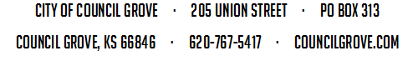
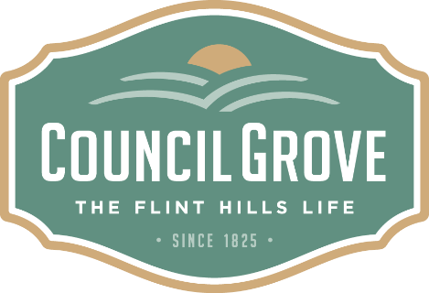

City Council Agenda

May 19, 2020

5:30 P.M. - City Hall

WELCOME AND CALL TO ORDER
PLEDGE OF ALLEGIANCE
PUBLIC COMMENT PERIOD
Items not already on the agenda may be brought before the Governing Body. Persons must sign in to be eligible. (Three minute maximum time limit). After three minutes, items will then be voted on to see whether or not to place the item on the next agenda.
CONSENT AGENDA:
- Minutes from the Previous meeting Pages 2 - 3
- Appropriations:
- Lake Cabin Transfers: C-1 & D-1 Pages 4 – 45
Motion: Seconded: Action: Abstention: Este. Cost: Appd. Cost:
OLD BUSINESS:
- Parks and Recreation Update:
Motion: Seconded: Action: Abstention: Este. Cost: Appd. Cost:
NEW BUSINESS:
- Washunga Days Update:
Motion: Seconded: Action: Abstention: Este. Cost: Appd. Cost:
- Adoption of New Building Codes:
  - International Building Code Pages 36 - 38
  - International Mechanical Code Pages 39 - 42
  - International Property Maintenance Pages 43 - 44
  - International Residential Code Pages 45 - 47
  - International Swimming Pool and Spa Pages 48 - 50
  - International Existing Building Code Pages 51 - 53
  - International Plumbing Code Pages 54 - 56
  - National Electrical Code Pages 57 - 61
Motion: Seconded: Action: Abstention: Este. Cost: Appd. Cost:
- Cares Act CDBG-COVID-19 Grant Discussion:
Motion: Seconded: Action: Abstention: Este. Cost: Appd. Cost:

Governing Body Comments:
Adjournment:

